Design Updates
URL:
http://us15.campaign-archive2.com/?u=12a794b2402eb103cba5c25f4&id=525bad20c6
- Post my Flight Button - Button needs to be moved further left aligned with red line
Currently:
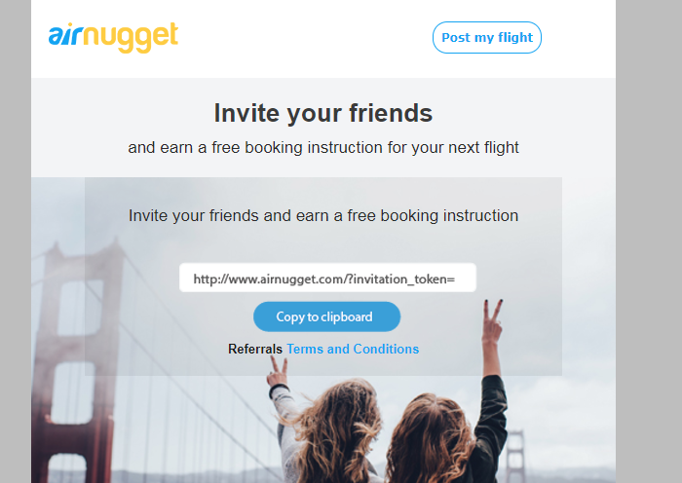
Updated:
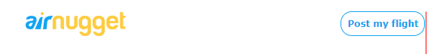

- Text should be inside image not on a grey background – please follow same design as provided (image only no grey background) also image is uploaded too large and cut too much (should see more of the image)
Currently:
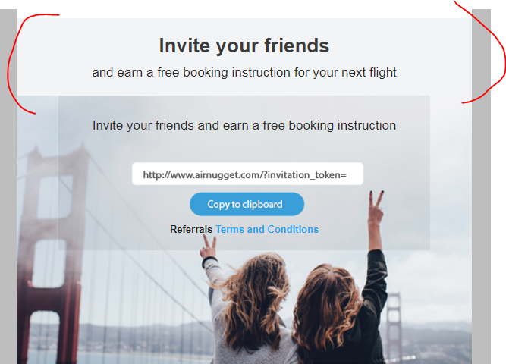
Update: Please follow same design as in provided designs
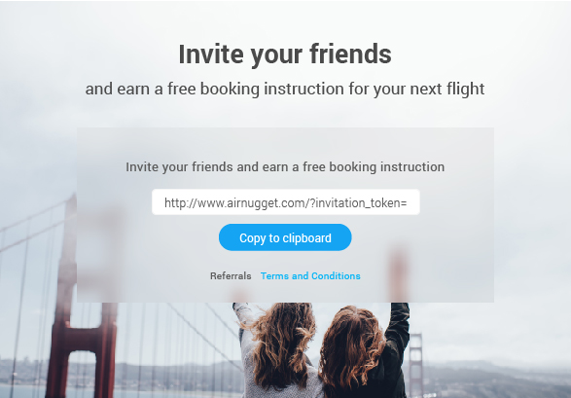

- Please Update Invite Friends link box
- Remove link field
- Update Button link to homepage
- Add copy above button (Code just above the footer)
Currently
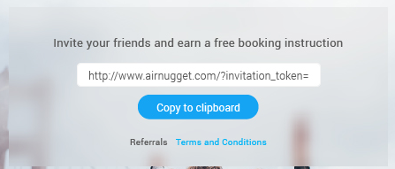
Update
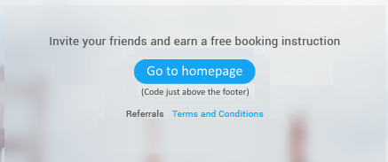
- Update Link Terms and Conditions
https://airnugget.com/trust_and_safety/terms
- Update link

https://plus.google.com/116469662694192725459/about

